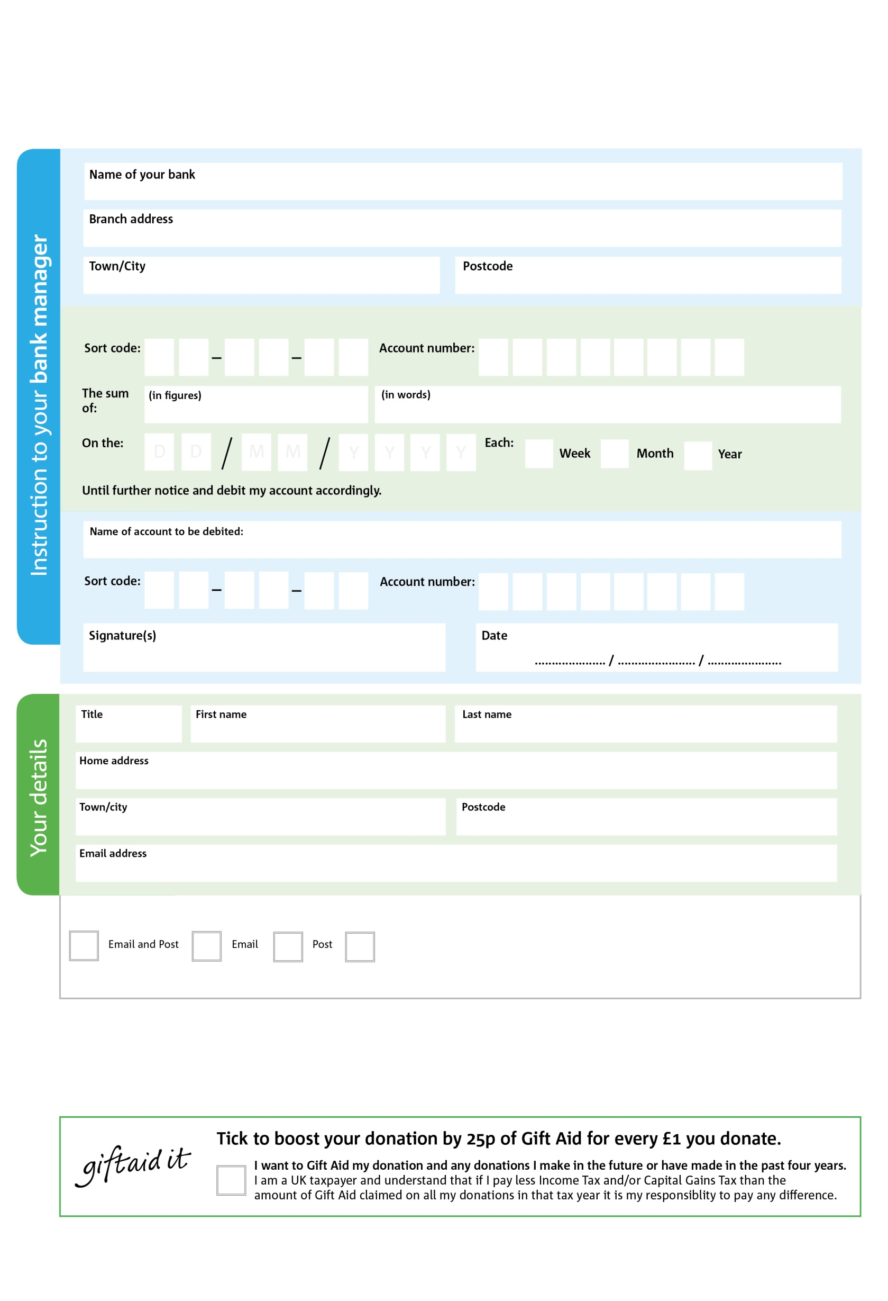

3

Please pay Knowsley Foodbank:

POSTAL ADDRESS: Knowsley Foodbank, Unit E,Centro Park Gores Road, Kirkby Industrial Park, Beckett Close, Liverpool, L33 7NX

Reg. Charity No: 1196064 Reg. in England & Wales

81

V

38

V

57

V

71

V

51

V

966

V

33

V

4999

V

**Please pass this form onto the foodbank, using the foodbank’s address at the bottom, who will save a copy for their records.   
They will then send it onto your named bank or building society.**

0

8

5

0

2

We would love to keep you up to date with information about Knowsley Foodbank. Please tick your preference:

You can change your preferences any time by contacting us on 01514826089 or emailing us at finance@bighelpproject.com

I do not wish to receive future communications from Knowsley Foodbank

**Data protection**

*'Knowsley Foodbank is committed to protecting your privacy and will process your personal data in accordance with current Data Protection legislation. Knowsley Foodbank collects information to keep in touch with you and supply you with information relating to our work. To unsubscribe from our newsletter, send a message to the email address above with the word unsubscribe in the subject line. A full data privacy statement for financial donors is available from the foodbank on request.’*

**Standing Order Mandate**

**Knowsley Foodbank**

You can change your preferences any time by contacting us on XXXXXXXXXXX or emailing us at XXXX@XXXXXXXXXX.foodbank.org.uk

I do not wish to receive future communications from XXXXXX Foodbank